Configuring and Managing IPTables

IPTables can be tricky because it’s not a service but a command for managing rules that decide how to handle network traffic.

Step 1. Return to the Ubuntu machine.

Step 2. To save the IPTables settings to a file, first enter root privileges with the following

Command: sudo su

Entering the password when prompt

Step 3. Now that you are under root access, enter the following command to save the rules you just created: iptables-save > /etc/iptables/rules.v4

It's best to avoid staying in root mode longer than needed to prevent accidental changes that could harm your system. Exit root mode with the following command: exit

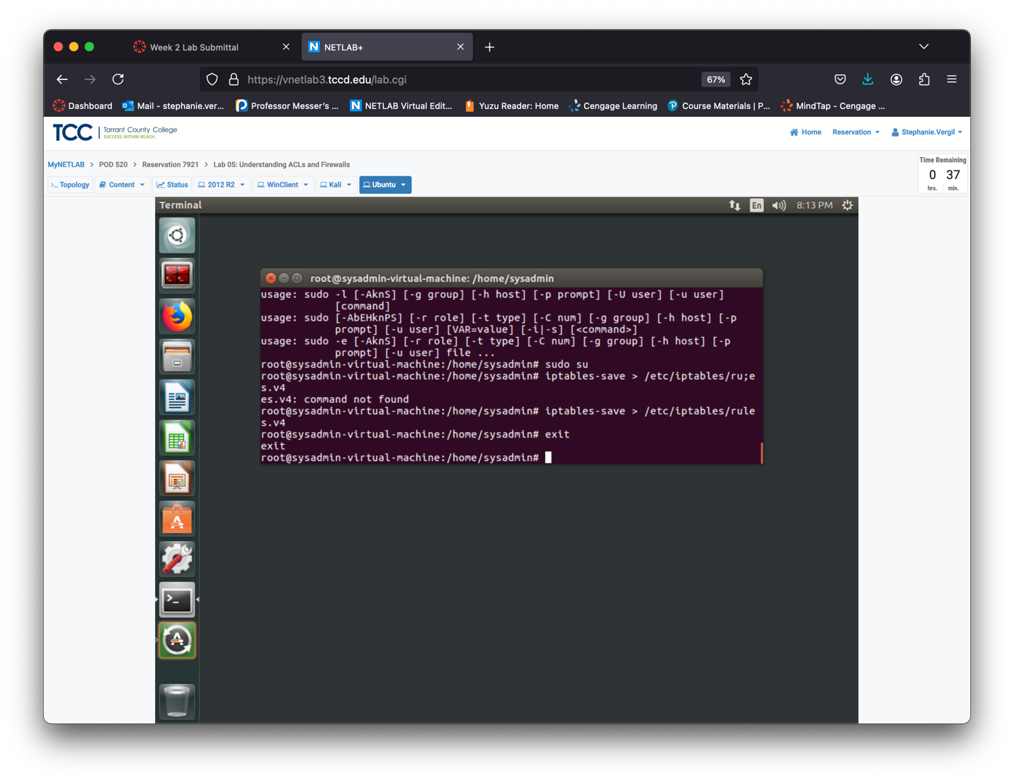

Step 5. Using switches with the iptables command lets you see more details. Enter the following command to check the current setup: sudo iptables -n -v -L --line-numbers

You’ll see there are 7 INPUT chains and 5 OUTPUT chains.

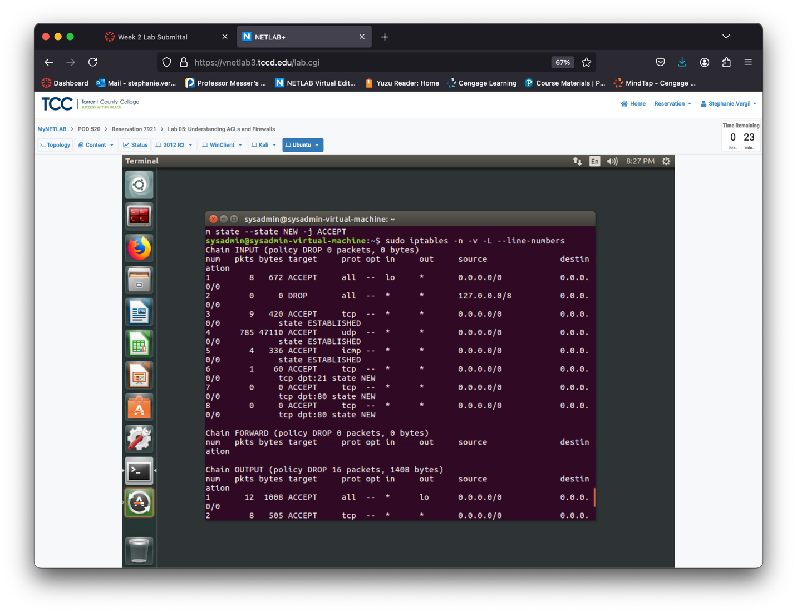

he -n (or --numeric) switch shows IP addresses and port numbers in numeric format. Without it, the program tries to display them as hostnames or services.

The -v (or --verbose) switch provides detailed output, including rule hit counters, which is useful for debugging.

The --line-numbers option adds line numbers to each rule, indicating its position in the chain.

Step 6. To delete rules one at a time, use the -D switch. The command format is iptables -D <Chain> <Rule number>. Practice deleting a rule from the INPUT chain with this command: sudo iptables -D INPUT 7

Step 7. Run the following command one more time: sudo iptables -n -v -L --line-numbers

Notice that you now only have 6 rules in the chain. The rule for port 80 has been deleted.

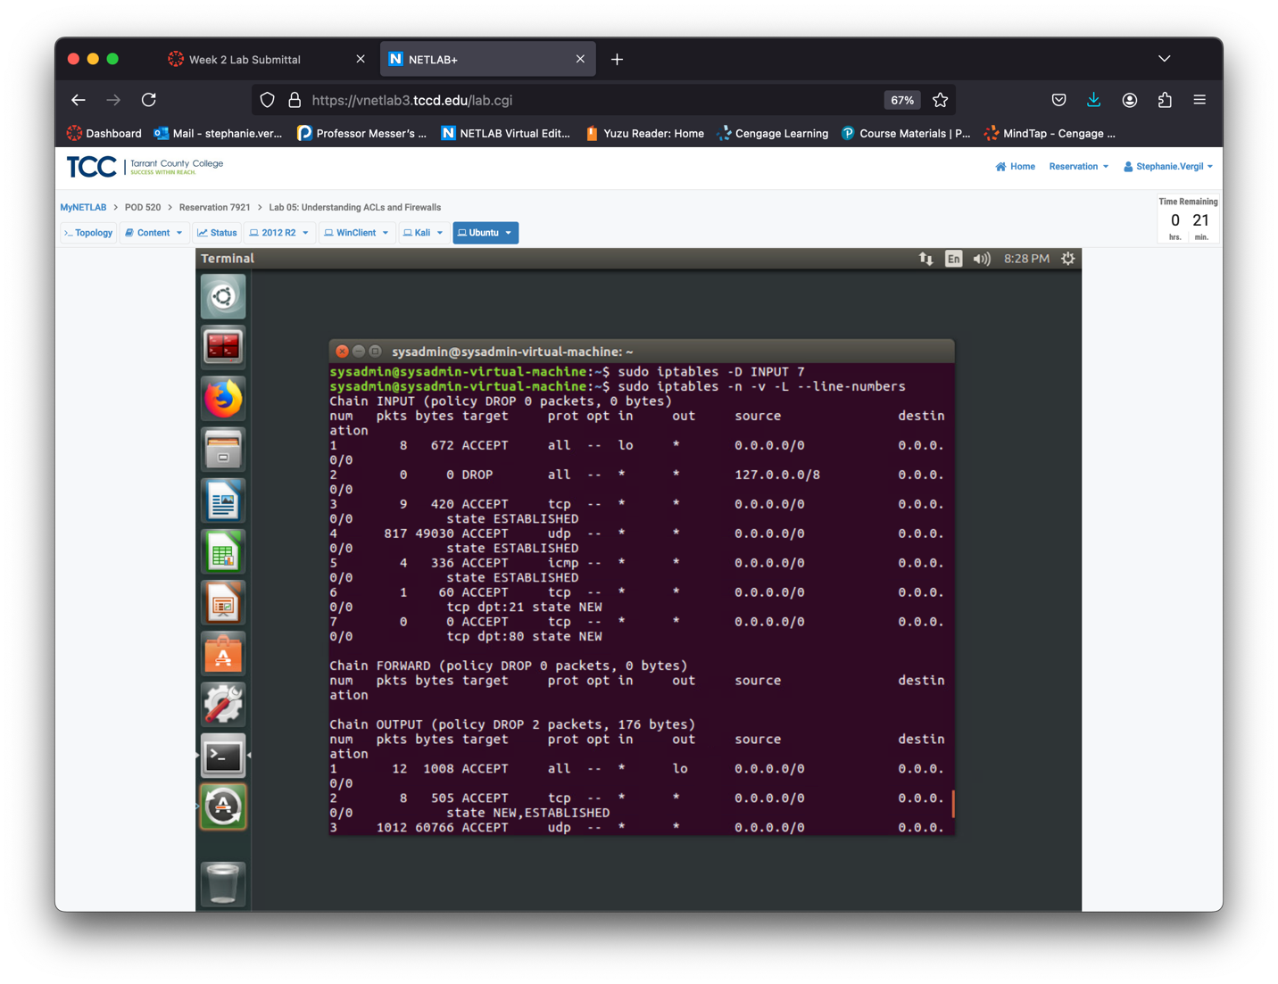

Step 8. To view the script on the Ubuntu machine that flushes IPTables chains and sets all traffic to accept, effectively disabling the firewall, enter the following command:

cat LabFiles/FirewallsAndACLS/disableFirewall.sh

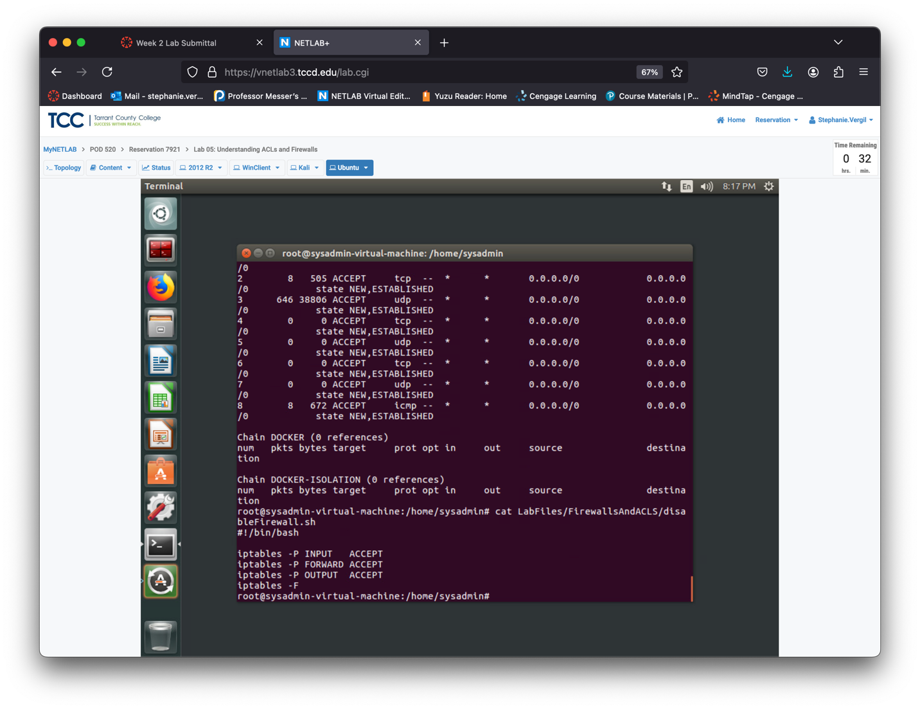

Step 9. Run the script to clear your firewall and disable it with the following command: sudo ~/LabFiles/FirewallsAndACLS/disableFirewall.sh

Step 10. Confirm that your firewall has been flushed with the following command: sudo iptables -L

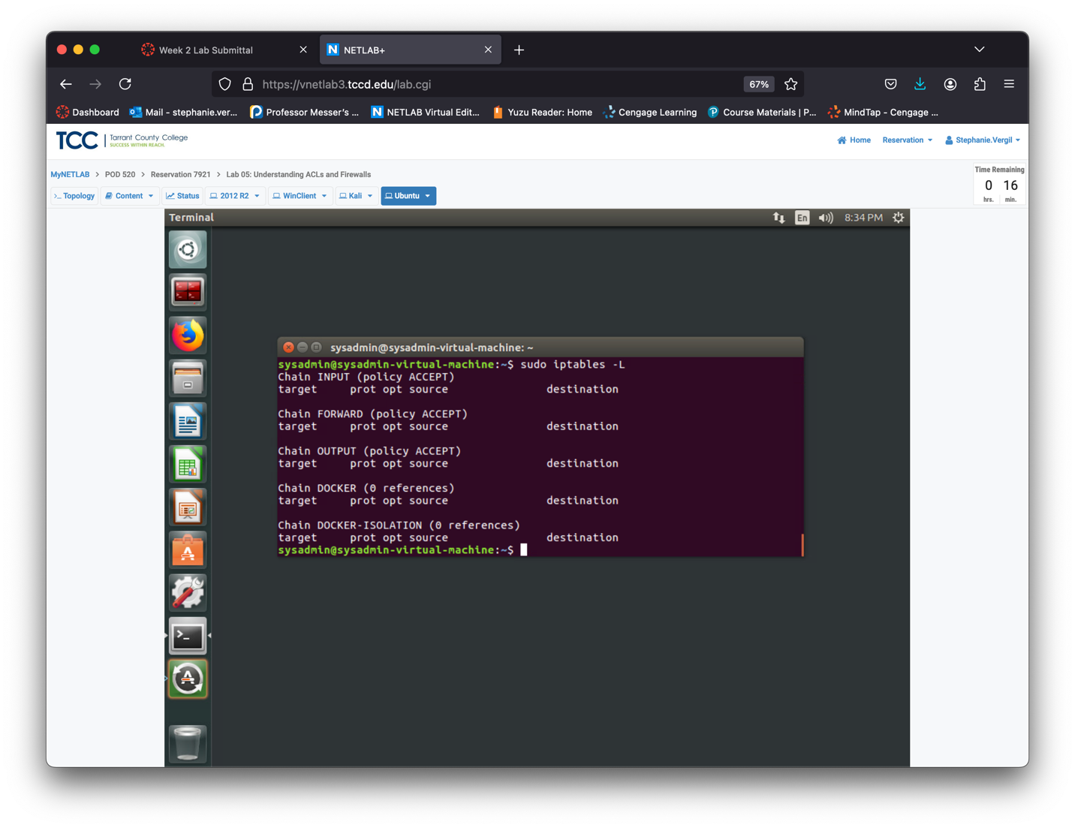

Step 11. Now that all traffic is allowed, set the Ubuntu machine to listen on port 5000. Enter the following command: ncat -4 --keep-open --listen --source- port 5000

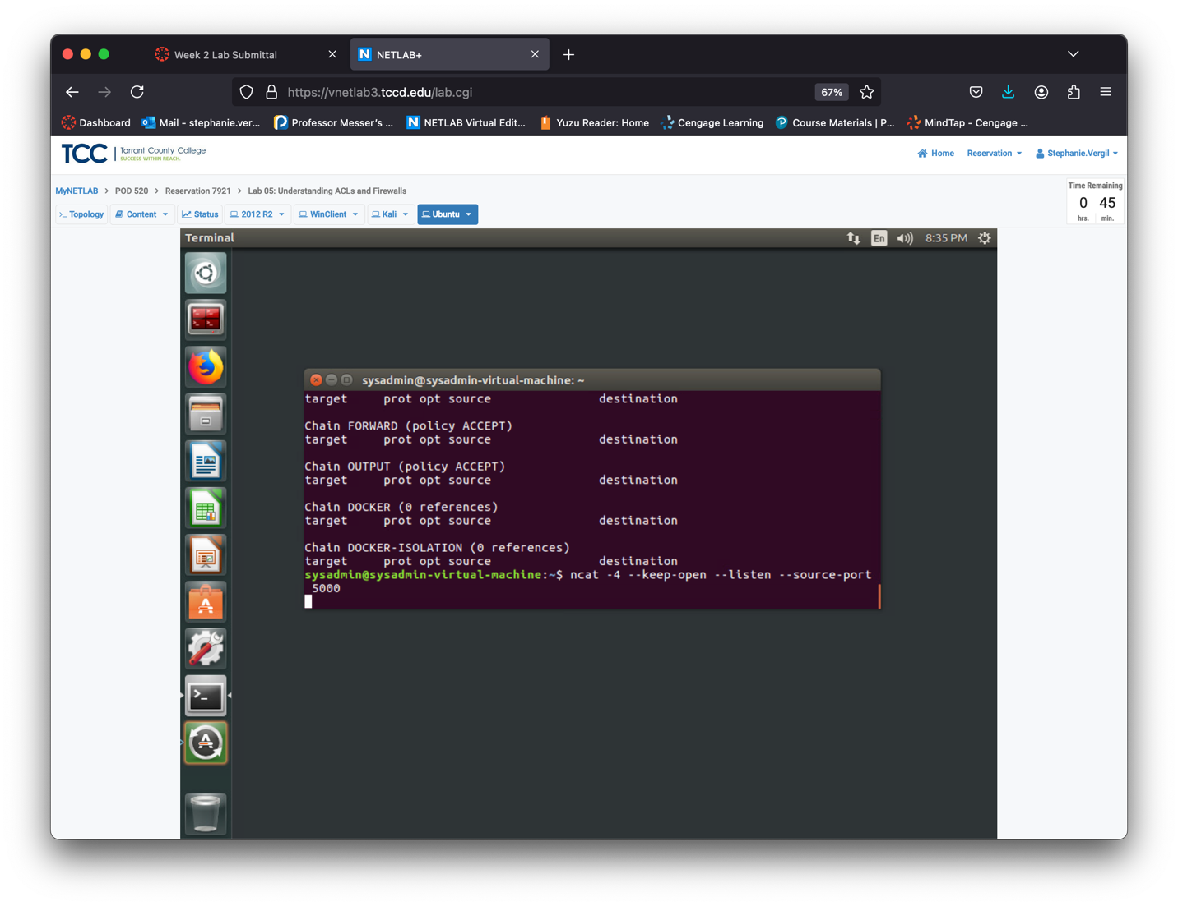

Step 12. Return to the Kali machine.

Step 13. Use ncat to connect to the Ubuntu machine via port 5000. Enter the following command: ncat 192.168.1.4 5000

Step 14. Type hello, and press ENTER.

Step 15. Press CTRL+C to end the ncat process.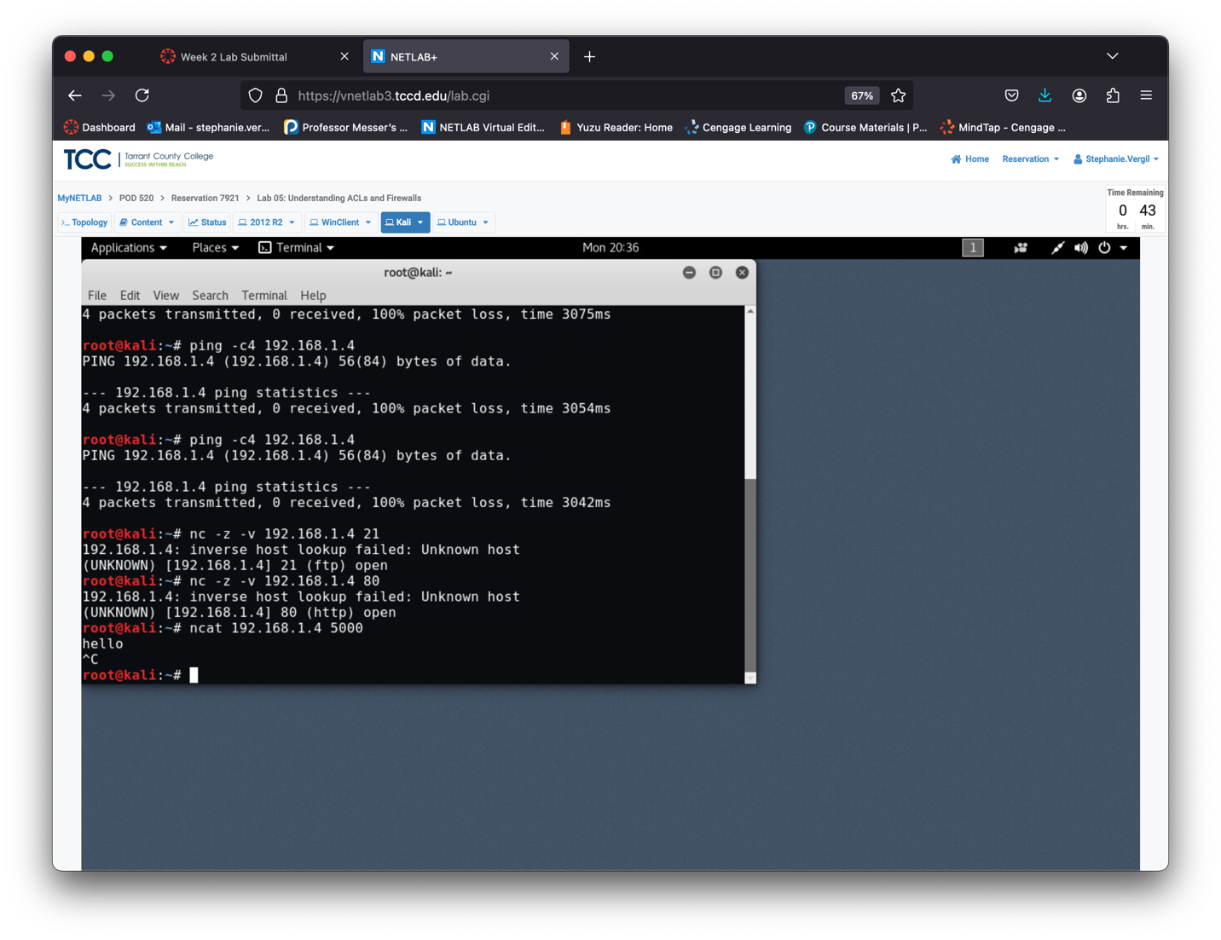

Step 16. Return to the Ubuntu machine.

Step 17. Once on the Ubuntu machine, confirm the word hello has appeared in the Terminal window.

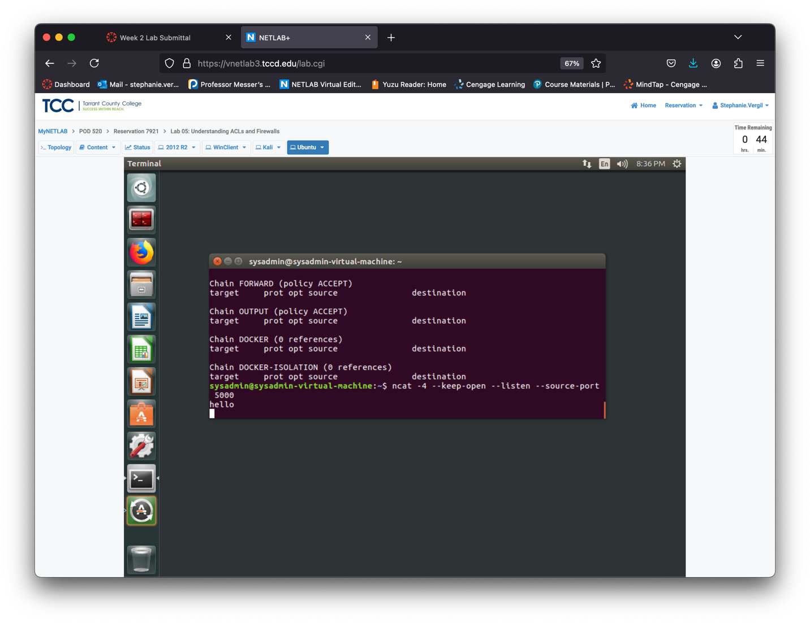Step 18. Open a new Terminal window by right-clicking the Terminal icon and selecting New Terminal. Leave current terminal with the ncat process on it running.

Step 19. Once the Terminal window loads, enter the following command: sudo iptables -A INPUT -p tcp –dport 5000 -m state --state NEW -j ACCEPT

Step 20. Enter the following command and observe the hit counter: sudo iptables -vL INPUT

This is a very useful tool for determining if the rules you have created are working as intended.

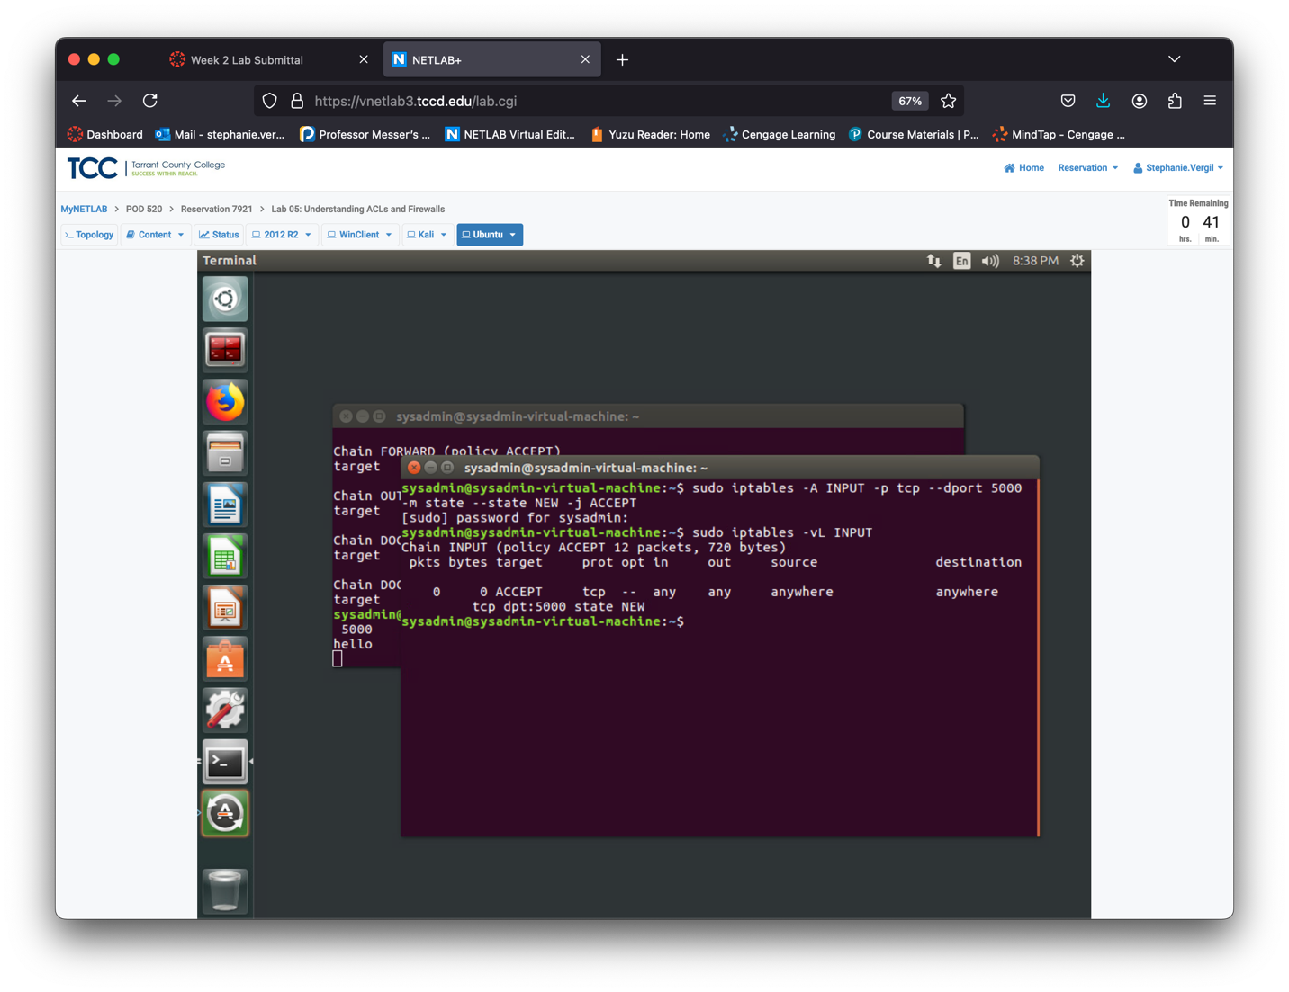Step 21. Return to the Kali machine.

Step 22. Enter the following command once more to access the Ubuntu machine via port

500: ncat 192.168.1.4 5000

Step 23. Type hello and press ENTER.

Step 24. Press CTRL+C to end the ncat process.

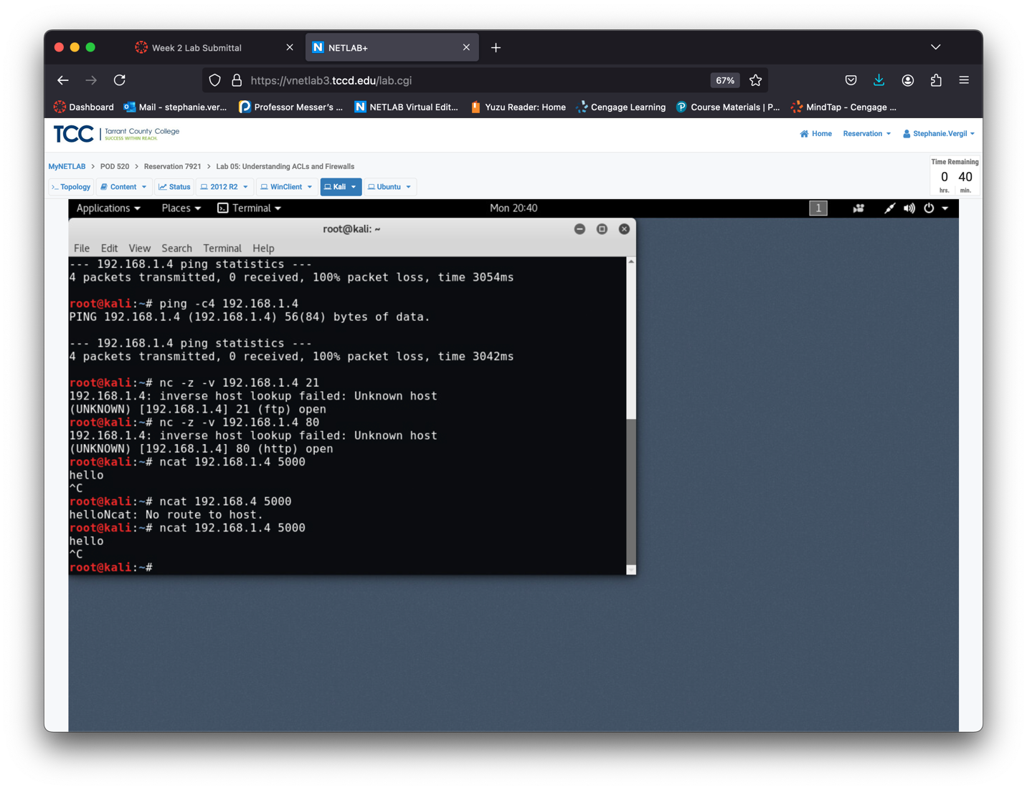

Step 25. Return to the Ubuntu machine.

Step 26. Confirm that a second instance of the word hello has appeared in the Terminal with the ncat process running in it. 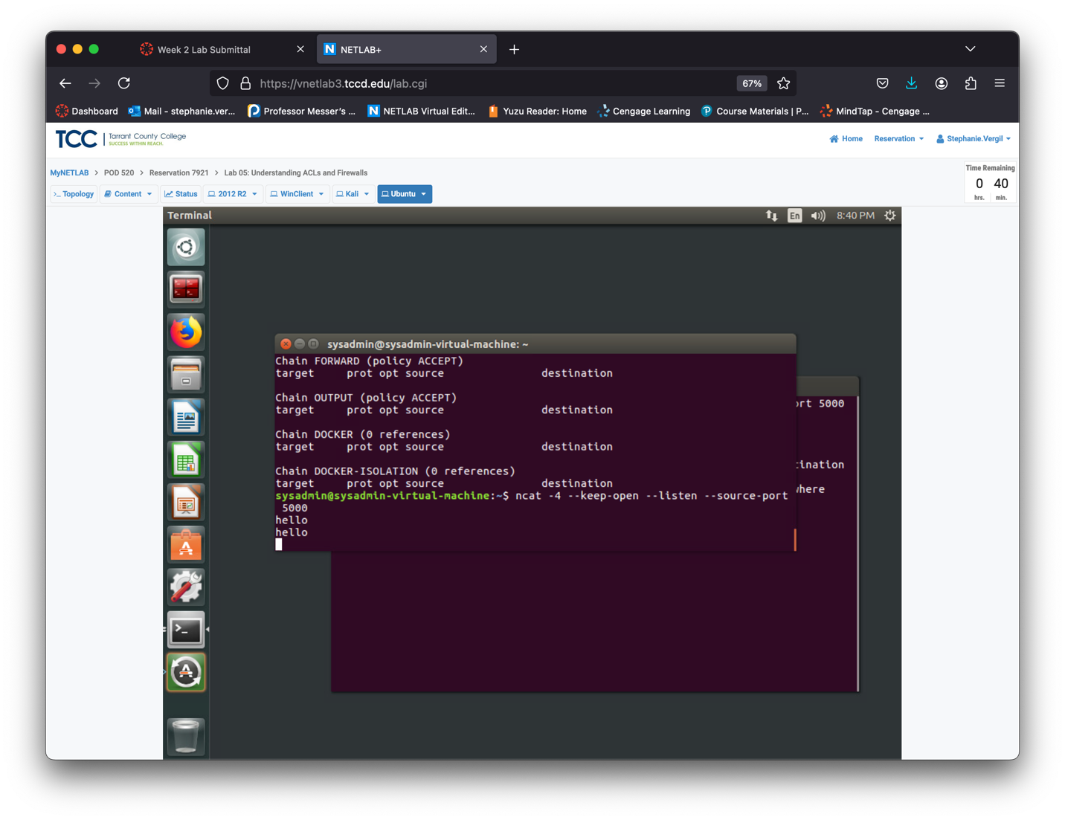Step 27. In the Terminal window that does not have the ncat process running, enter the following command to check the hit counter. It should show an increase by one due to the traffic from the Kali machine: sudo iptables -vL INPUT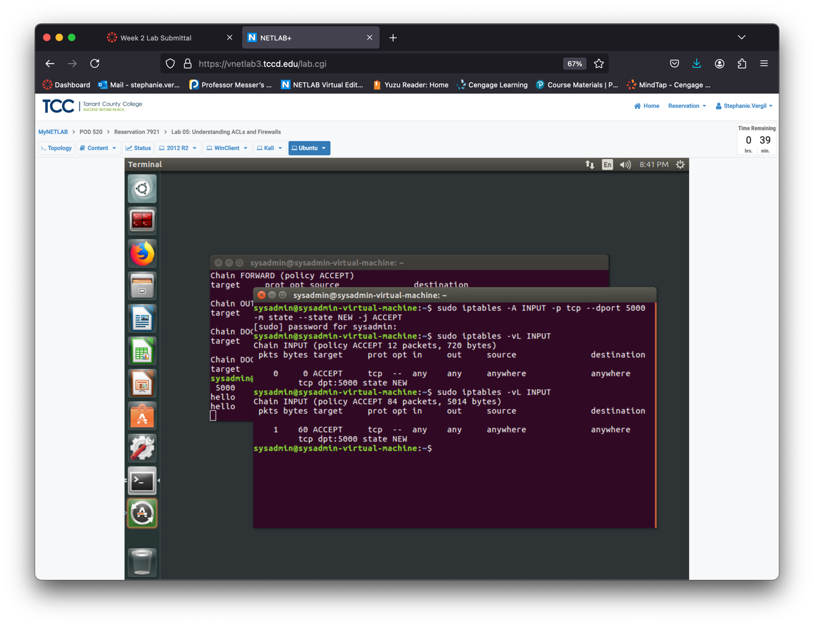

Step 28. identifying open ports is a crucial skill. To set up an environment for this, enter the following command to run the randomports script, which will open a specified number of ports: sudo ~/LabFiles/FirewallsAndACLS/randomports.sh

Step 29. Select 10 random ports when prompted and press ENTER.

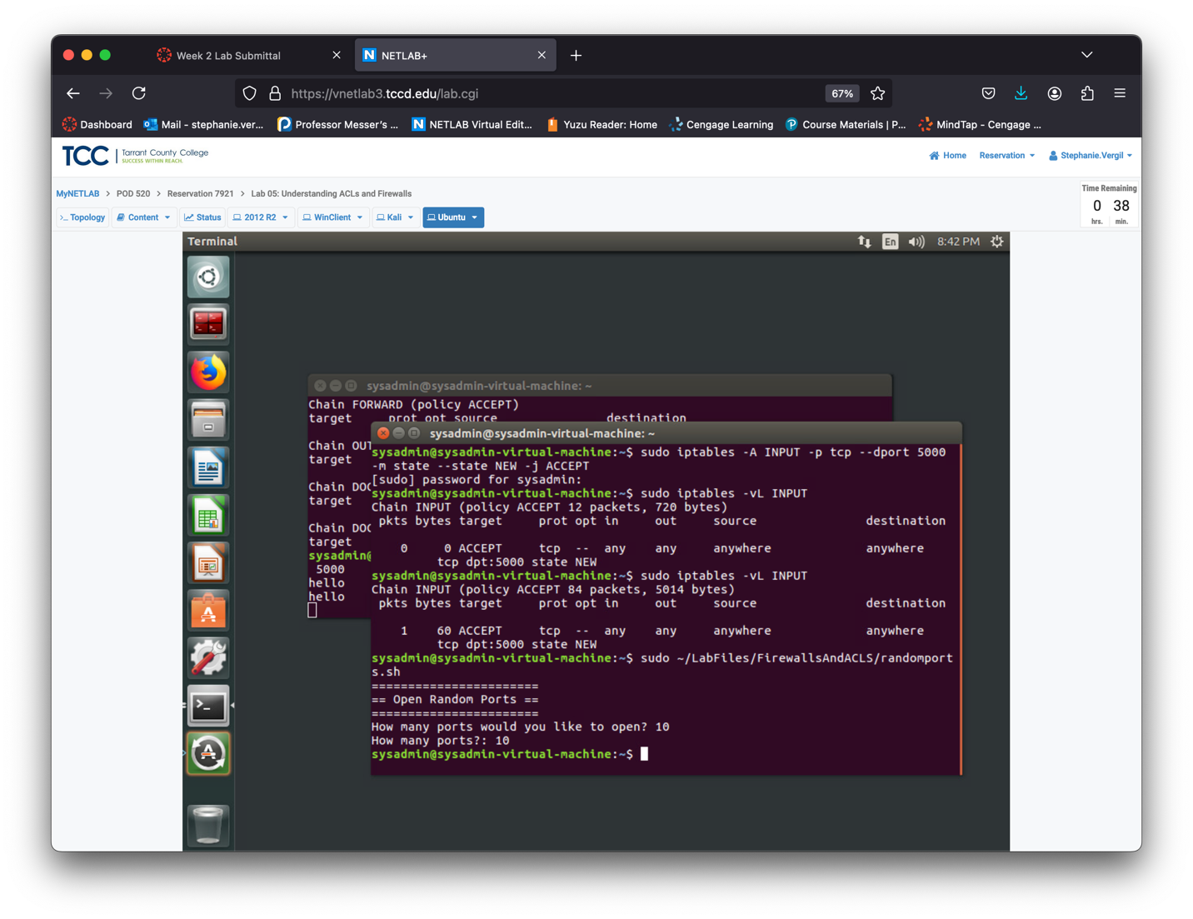

Step 30. Return to the Kali machine.

Step 31. Use the following command to run a port scan on the Ubuntu machine. Ports that are open will be indicated. This helps identify which ports to block and which to keep open for functionality. After the scan completes, you can close the Terminal window: nmap -sS -n -T 4 --reason --script=banner -p- 192.168.1.4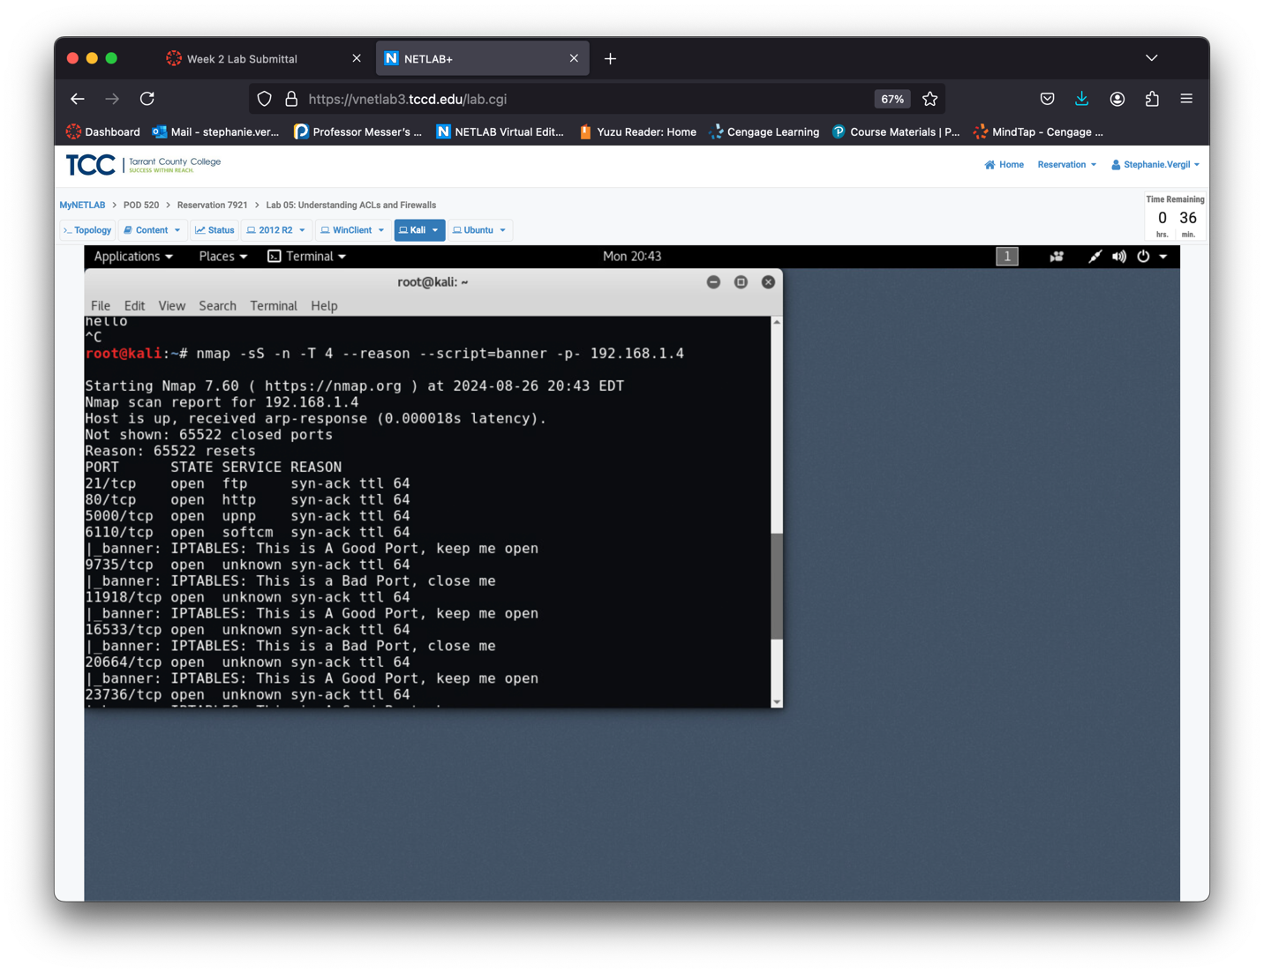

Step 32. Return to the Ubuntu machine.

Step 33. Based on the scan results from the Kali machine, you can now add IPTables rules to block traffic on unwanted ports. Since the ports are random, specific steps aren’t provided. Unlike NEW or ESTABLISHED states, RELATED states initiate new connections tied to existing ones. These are tracked using ip_conntrack_*. Enter the following command to view the current connection tracking state: sysctl

net.netfilter.nf_conntrack_helper

Step 34. Enter the following command to enable connection tracking: sudo sysctl

net.netfilter.nf_conntrack_helper=1

Step 35. Likewise, you can disable connection tracking with the following command: sudo sysctlnet.netfilter.nf_conntrack_helper=0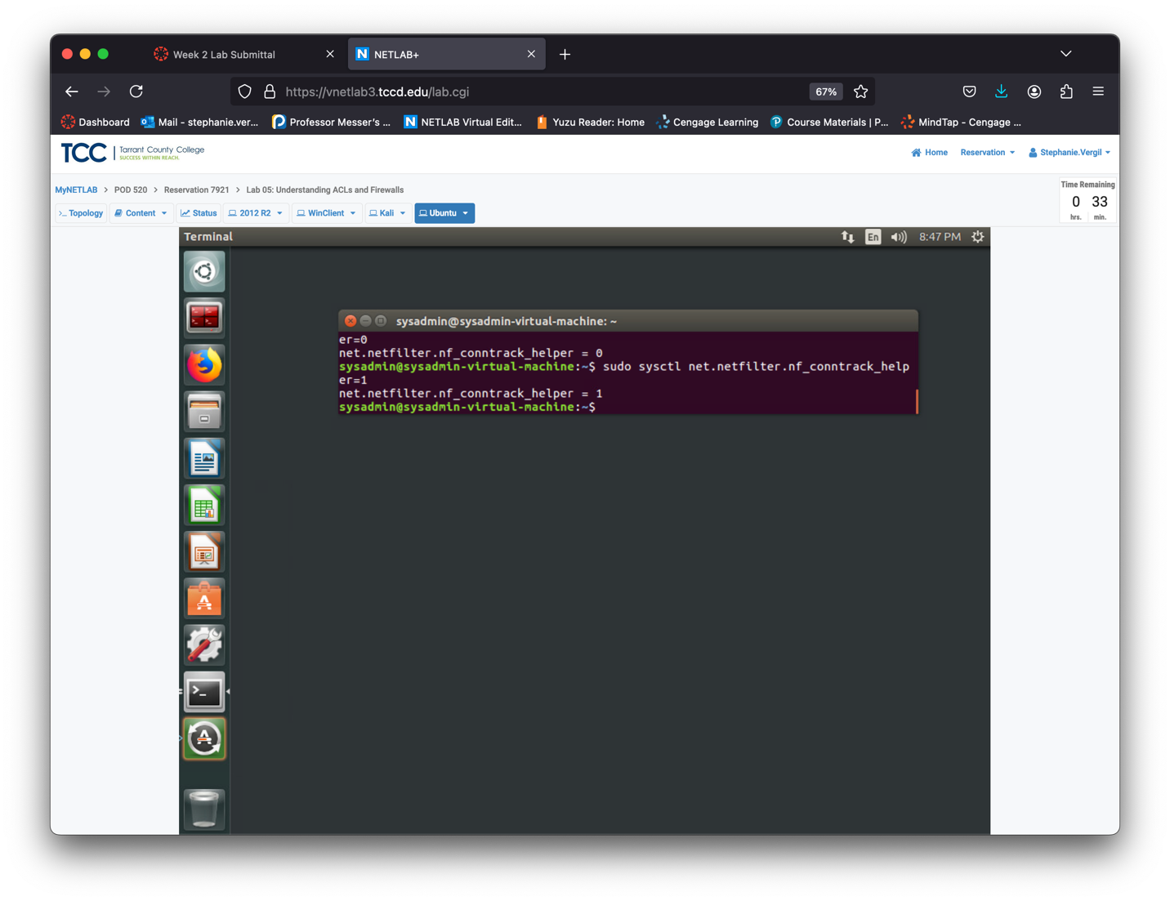

Step 36. You can show any available connection tracking kernel modules with the following command: sudo find / -name nf_conntrack_* | grep .ko

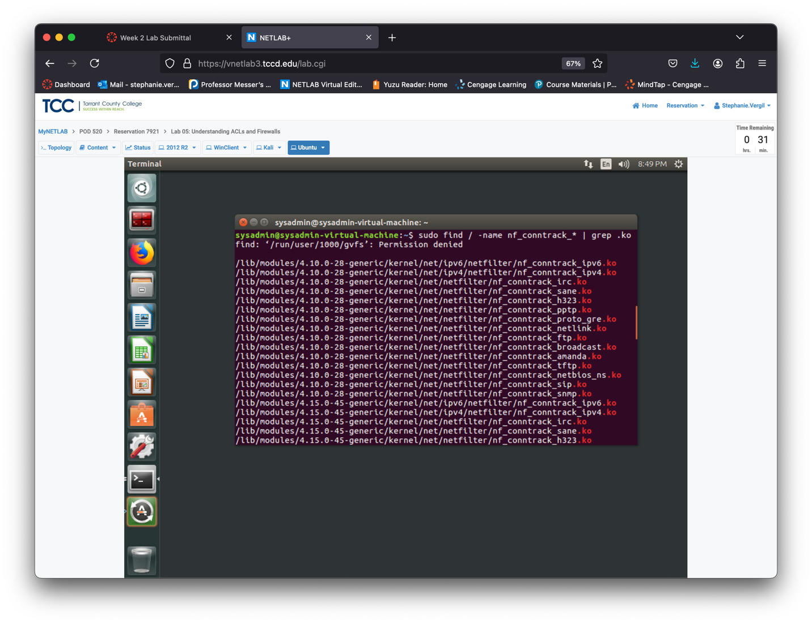

Step 37. Press CTRL + C to return to the terminal prompt. To activate a connection tracking kernel module, such as nf_conntrack_netbios_ns, enter the following command: sudo modprobe nf_conntrack_netbios_ns

